**Seyed Hossein Mohammadi (96222096)**

**Project 2 – Population Modeling**

1. Fully connected 800 excitatory and 200 inhibitory AELIF with the following config with J=6.5:



Test 1:

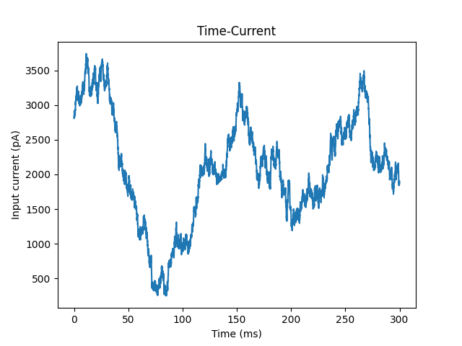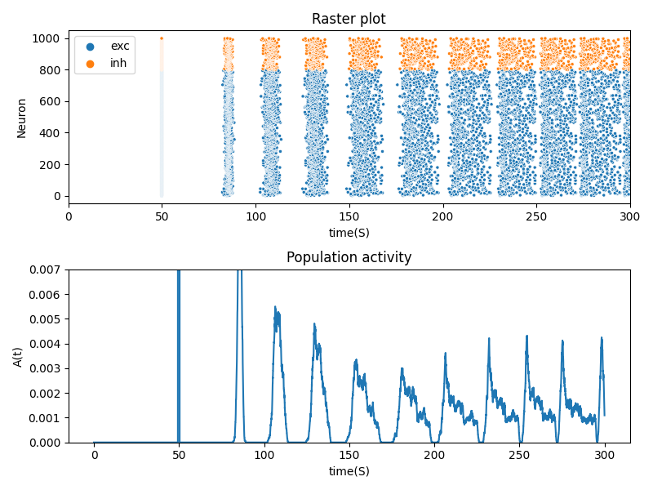

Test 2:

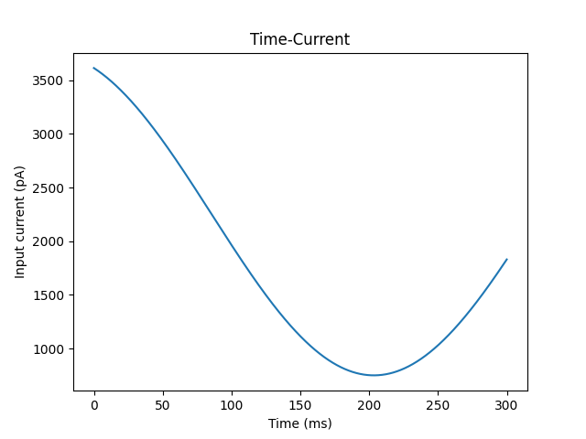

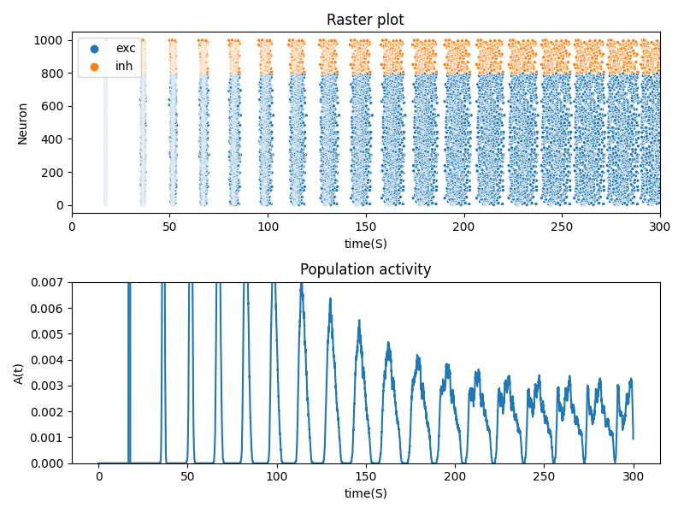

Test 3: similar to test 1 but 3 times the time.

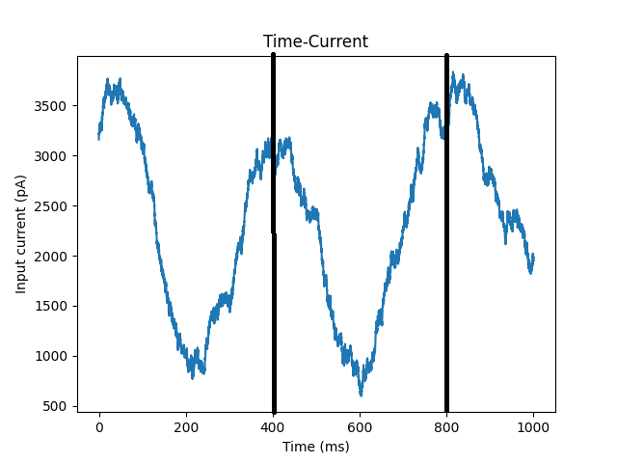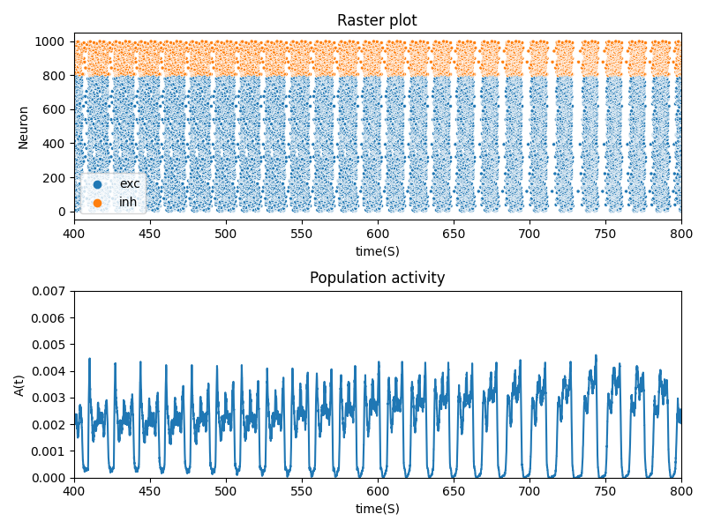

2-

POP1: fully connected 800 excitatory and 200 inhibitory AELIF with the following config with J=6.5



POP2: fully connected 300 excitatory and 100 inhibitory LIF with the following config with J=5.5:



Pop1 is fully connected and directed to pop2 with J=10.

Test 1:





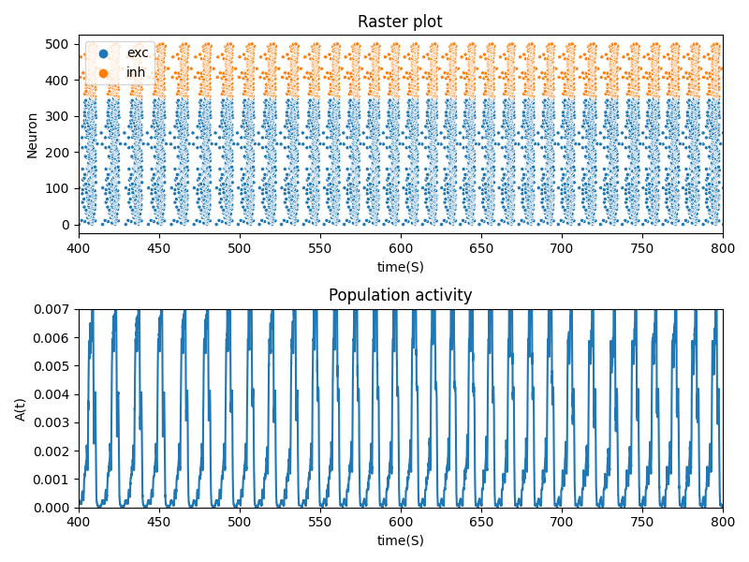

Test 2:

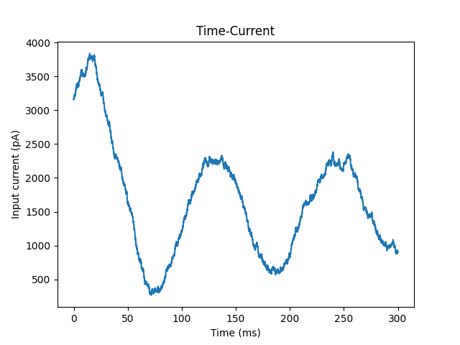

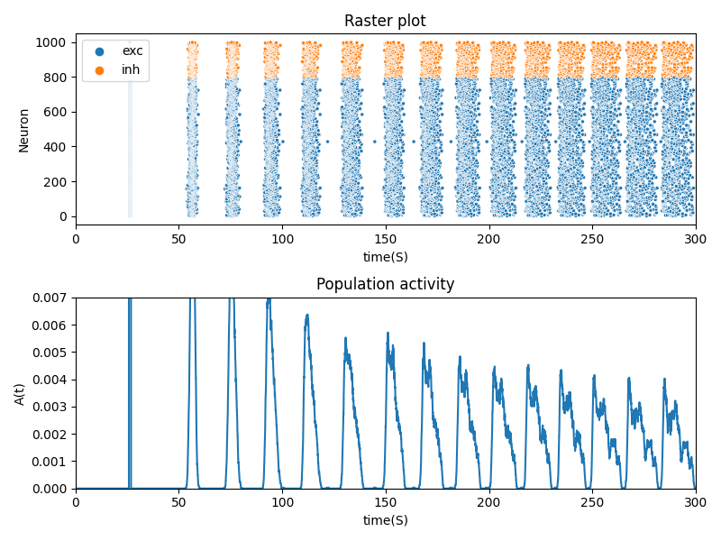

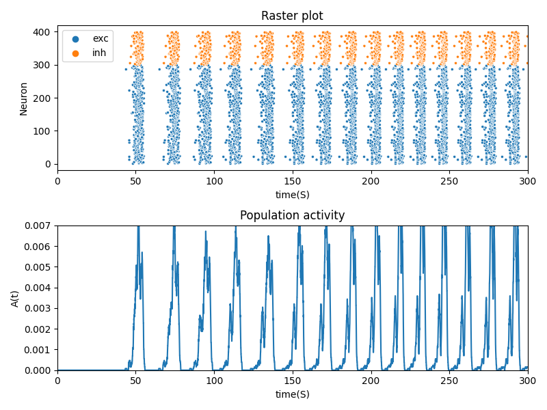

Test 3:

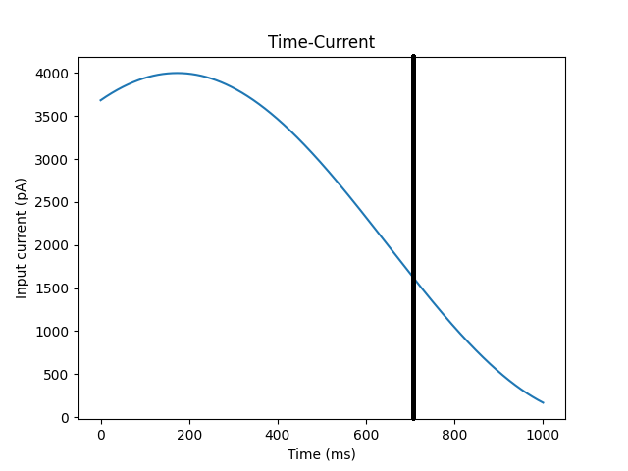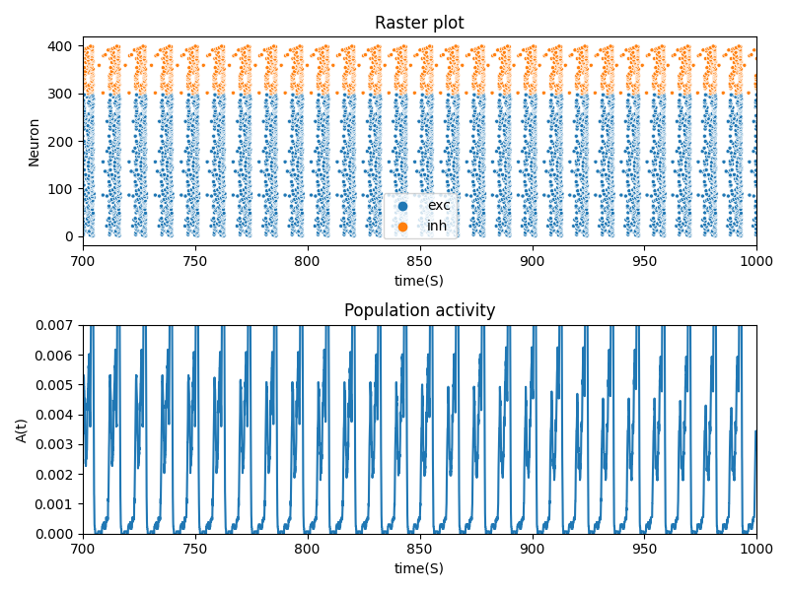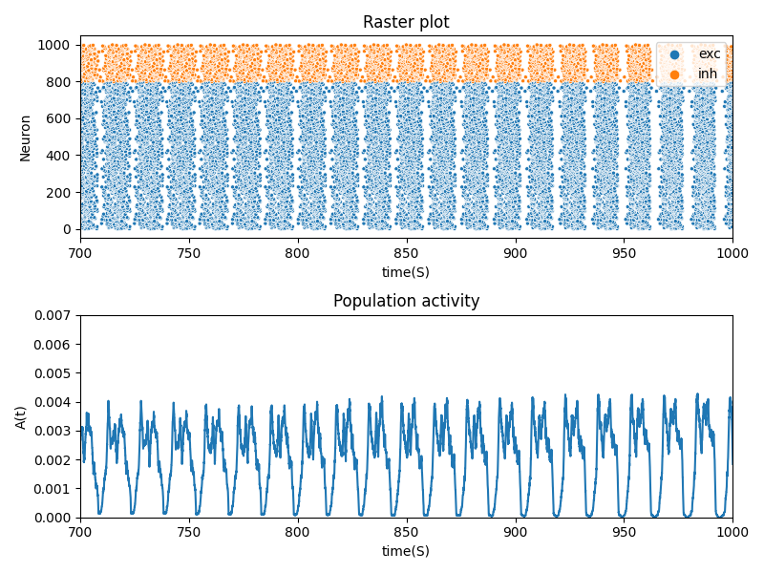

Extra –

POP1: Fixed Coupling connected (p=0.01) of 800 excitatory and 200 inhibitory AELIF with the following config with J=6.5



POP2: Fully Connected 300 excitatory and 100 inhibitory AELIF with the same config with J=2.5:

Pop1 is Gaussian connected and directed to pop2 with J=6 and sigma=1.

